Scientific Tools and Measurement
Day 9
Points of View: Tools of the Trade
You will work to show what you’ve learned about scientific tools and measurement from several different viewpoints.
1. Review the lesson in your Ohio Science Fusion Student Edition Pages 42-53.
2. Complete your assignment, and practice presenting your work. You could be asked to share your work with your class when you return school.

 | Vocabulary Make a picture dictionary that defines and describes vocabulary terms from this lesson, along with other important words related to scientific tools and measurement. Include a diagram or illustration with for each word.
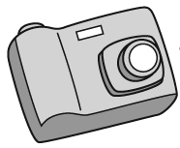 | Examples Take several photos that show a measurement being taken with the proper tool. Then write or draw descriptions that explain what the measurements can tell us and how information from them can be used.
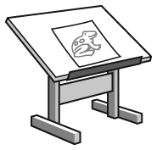 | Illustrations Draw diagrams that explain five different properties that scientist measure. Be sure to include the SI unit that is used to tell about the property and which tool is used to measure it. Note whether the unit is a base unit or a derived unit.
 | Analysis Select an object from your home, a nearby location, or choose an event you’d like to study. Record both qualitative and quantitative observations to describe the object or the event.
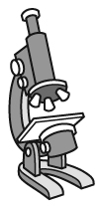 | Measurement Gather various tools found around your home that can be used to measure length (e.g. a ruler, yardstick, calipers, tape measure, ). Measure the diameter of a coin. Make a table that will be used to record your measurements, listing each tool. You will use each tool you gathered and record each measurement you take. When you get back to school compare the precision and accuracy of your readings to a classmates. You may need to go over what distinguishes precision and accuracy. Explain how these differences could affect the outcome of a scientific investigation.
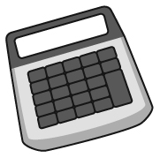 | Calculations Look up at least five measurements that describe very small or very large values, such as something very large or small, or something very far away. Make sure the value is given in SI units. If the measurement is given in standard notation, convert the value to scientific notation. If it is given in scientific notation, the convert it to standard notation and apply SI prefixes (if appropriate) to the numbers.

